**PRESS RELEASE –**

**MERVYN RABUNTJA, HERMANNSBURG STYLE WATERCOLOUR ARTIST**

**IN THE TRADITION OF ALBERT NAMATJIRA,**

**WILL BE PAINTING IN AN OPEN STUDIO SCENARIO AT TALI GALLERY IN ROZELLE**

**SATURDAY 23RD FEBRUARY 2012**

**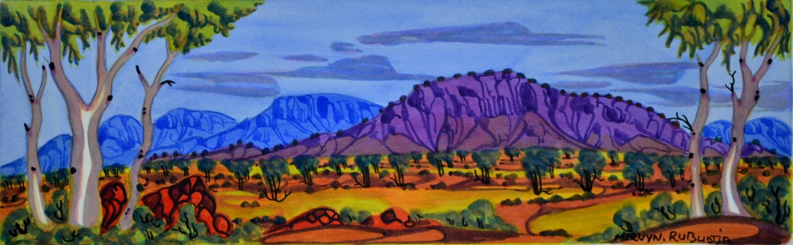**

**image:  Mervyn Rabuntja “Mt. Riddick”, NT**

**BACKGROUND**

Watercolour artist, Mervyn Rabuntja is travelling to Sydney from Alice Springs with Iris Bendor from the Ngurratjuta Many Hands Art Centre for a weekend of events in Sydney in late February.

Mervyn learnt to paint from his father (who was taught to paint by Albert Namatjira), who also passed down the law and the traditional learning of his people that are incorporated into Mervyn’s paintings.   The current artists who paint landscapes in watercolours in what is known as the Hermannsburg style, are the third and fourth generation, related to Albert Namatjira by blood or skin group.   Many of these artists are on exhibition at Tali Gallery  (including Albert Namatjira jnr, Douglas Abbott, Elton Wirri, and Peter Taylor as well as artists whose work were purchased by the Art Gallery of NSW in 2012:    Gloria Pannka, Lenie Namatjira and Ivy Pareroultja.)

**TALI GALLERY EVENT – SATURDAY 23RD FEB – 10am to 5pm**

On Saturday 23rd February, Mervyn will be painting at Tali Gallery in an Open Studio Scenario and people are welcome to come and see him in action.

There will also be some additional special events and talks throughout the day at Tali Gallery.  The events are free other than the children’s workshop where the fee will cover materials and tuition.

Events include:

* 10am Welcome to Country and a co-workshop with the Combined Art Societies of Sydney Artist of the Year, Julie Simmons;
* 11am  a children’s workshop with young Indigenous artist Nikeeta Haverfield ($25 per child, bookings essential);
* 2.30pm  a talk in the afternoon by Summer Hill resident, Martin Edmond who’s writing a book on the first and most famous Hermannsburg watercolour artist,  Albert Namatjira and the artist who taught him to paint in a European style, Rex Battarbee

There will be other events during the course of the day and these will be published on the Tali Gallery website with times and further information. <http://taligallery.com.au/visiting-indigenous-watercolour-artist-february-23/>

Additional input will include participation and a film screening from the Friends of the Namatjira Project who supported the artists to travel with the play recently performed at the Belvoir Street and Riverside theatres.

It is very fitting that Mervyn will be painting in the Leichhardt Municipality as Mt. Leichhardt in the outskirts of Alice Springs in the Northern Territory is one of his subjects.

WE WOULD LIKE TO THANK TILLY’S IN ROZELLE for their sponsorship support in supplying Mervyn with materials such as Winsor watercolour paints during his visit.

**STATE LIBRARY, SYDNEY - UNIVERSITY OF WESTERN SYDNEY EVENT – SUNDAY 24TH FEBRUARY**

On Sunday, Mervyn will be participating in a panel at the State Library of NSW in the city along with a group of interesting people from various parts of Australia who are knowledgeable about Albert Namatjira’s life, his painting and the Hermannsburg ‘school’ of watercolourists.   This is being sponsored by the University of Western Sydney.  
   
As you’ve undoubtedly heard as it was reported in the Age, SMH etc, the two Ghost Gum Spirit trees Albert was famous for painting have been destroyed by an arsonist.   The impact that Albert Namatjira  <<http://www.ngurart.com.au/about/albert-namatjira/>> had on Australian landscape painting made him the most well known Aboriginal Australian of his time, leading to his special status as the “first Aboriginal citizen”.

**ABOUT MERVYN RABUNTJA**

Mervyn’s language group is Western Arrernte and his skin name is Japanangka.  He was born at the Telegraph Station in Alice Springs in 1958 and moved to Hermannsburg with his family at the age of 13 where he first watched watercolour paintings being created by his uncles, Albert Namatjira’s sons:  Maurice, Oscar and Keith.  Arnulf Ebatarinja, another uncle, gave him some watercolour paperboard and told him to paint and when Mervyn’s family moved back to Alice Springs again in 1975, he began to paint with Basil Rantji who taught him how to mix colours.  He then watched and worked alongside his father.  Mervyn’s work is distinctive – clearly Hermannsburg yet unique in its stylised treatment of landscapes at Mt Riddick, Mt Leichhardt, the MacDonnell Ranges and views in regions around Alice Springs, with clear and vivid colouring.

Mervyn’s father, Wenton Rabuntja Pengate, was an important Lawman and a respected member of his community who worked hard for Aboriginal rights and protection of the land and worked alongside the Central Land Council, also assisting with the Mabo agreement.  He was also a famous artist and the subject/co author of the book “And the Town Grew Up Dancing”.   Wenton was taught to paint by Albert Namatjira (they are related by skin group).

Mervyn was accepted into the 2007 and 2008 Telstra Awards in Darwin and is included in collections of the Museum and Art Gallery of the NT, Araluen Galleries in Alice Springs and Ian Viner, QC.   He has been involved in many group exhibitions in Alice Springs since 2004,  and since 2008, has had work included in many interstate capital city and regional galleries, particularly in 2012 with 10 exhibitions.

Mervyn’s sister is a textile/soft sculpture artist at the Larapinta Town Camp and when I met her, she could really spin a yarn!  She creates very cheeky creatures in her art – e.g. a dog with a cocked leg!   I’m really looking forward to meeting Mervyn!

**ABOUT TALI GALLERY**   please see about us on our website :  [www.taligallery.com.au](http://www.taligallery.com.au)

We work with Aboriginal owned community art centres (around 25) and a few independent urban artists.   This provides art buyers with the best guarantee of authenticity, ethics and provenance.  The art centres send collectors and selected galleries such as Tali Gallery their best work on consignment as their representative sales outlet.  Each art centre artwork is accompanied by an art centre certificate.  The curator at the art centre sets the prices and invoices on sale and the money is returned to the community for distribution to the artist, to buy materials for all the artists and for special projects.

The government set up community art centres all over Australia to help create employment in remote regions.  They are supported with some funding, staffing and auditing  and provide an environment for positive cultural activity and self esteem.   They help the artists with their careers and exhibitions and much more.   They do constructive things for the community including providing special services and taking care of health needs, using part of the art proceeds to do so.

Not only does the art centre model of purchasing Aboriginal Art provide buyers with reassurance and certainty, but supporting Tali Gallery enables us to continue our own educational programs and special projects at this end.   Fair margins enable us to pay our rent and expenses, but we rely on help from a growing team of volunteer supporters some of whom have been working with us since we opened.

Di will be a running course on Understanding Aboriginal Art and Culture through Sydney Community College this year as well as continuing to lend Tali Gallery’s photographic exhibition to schools, libraries and organisations as part of their Reconciliation programs.   Tali Gallery hosts several child care centre and school visits through the year and regularly participates in Indigenous Scholarship and Literacy fundraising projects.

Tali Gallery recently won an award from Macquarie University for our efforts promoting Indigenous culture.

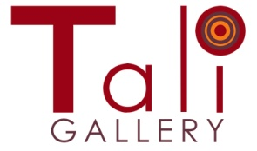Tali Gallery Pty Limited    ABN 80 003 519 542    IartC Ltd_logo

Winner Best of Sydney 2011 & 2012   Outstanding Business 2011/Finalist 2012

Winner Macquarie University Inclusive Community Awards:  September 2012  
M 04 1600 2700     T 9555 6555     W [www.taligallery.com.au](http://www.taligallery.com.au/)   f [Facebook](https://www.facebook.com/pages/Tali-Gallery/177330505645945)

                                             Location:     667 Darling Street   Rozelle   NSW   2039